**Introduction to Simulink in Matlab**

**LAB # 12**



**Spring 2021**

**CSE301L-Signal $ System**

Submitted by: **Ashfaq Ahmad**

Registration No: **19PWCSE1795**

Class Section: **B**

“On my honor, as student of University of Engineering and Technology, I have neither given nor received unauthorized assistance on this academic work.”

Student Signature: ______________

Submitted to:

**Engr Durr-e-Nayab**

August 15, 2021

**Department of Computer Systems Engineering**

**University of Engineering and Technology, Peshawar**

**OBJECTIVES OF THE LAB**

------------------------------------------------------------------------------------------------------------

This lab aims at the understanding and introduction to Simulink, an extension to Matlab.

------------------------------------------------------------------------------------------------------------

**What is Simulink?**

* Simulink is an extension to Matlab. In Simulink, you build block diagram models of dynamic systems instead of text code. It is easy to model complex nonlinear systems. Simulink can model both continuous and discrete-time components.

**---------------------------TASK ---------------------------**

* Design any signals and systems example in Simulink.
* Let I take a half wave rectifier.
* **HALF WAVE RECTIFER:**

**Circuit Diagram:**

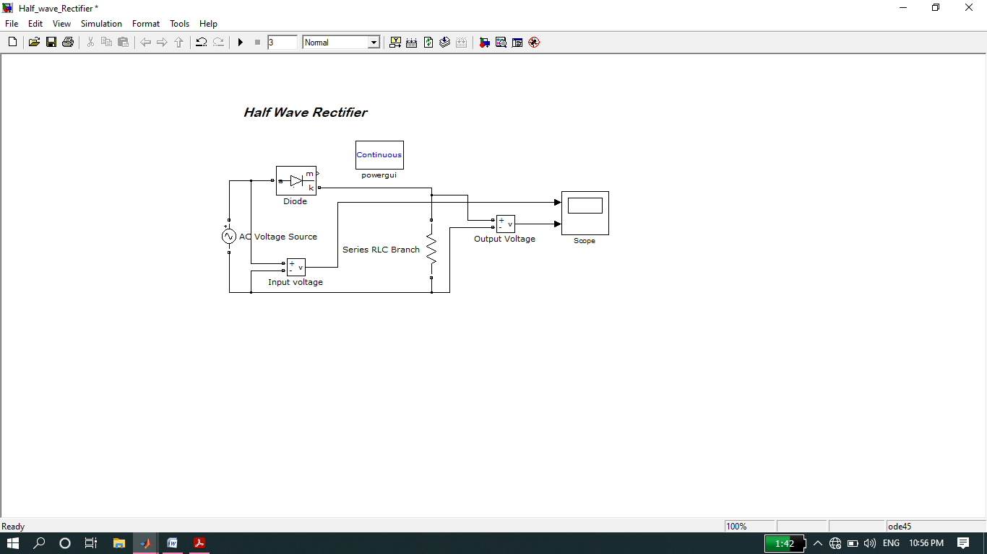

**Graph:**

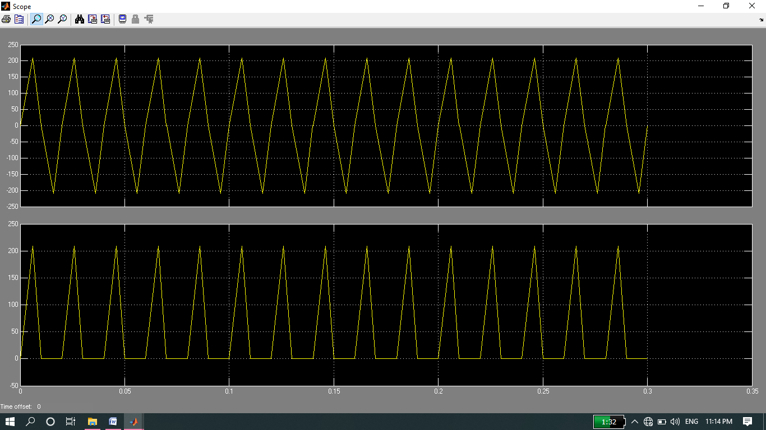

* **Now implementation of above circuit through coding in Matlab:**

Source code:

clc

clear all

close all

t=-2:0.002:2;

w=4;

xt=cos(w*t);

for i=1:length(t);

if(xt(i)<0)

xt1(i)=0;

else

xt1(i)=xt(i);

end

end

subplot(2,1,1);

plot(t,xt)

title('Input Sinusiodal');

subplot(2,1,2);

plot(t,xt1)

title('Half Wave Rectifier');

**Graph:**

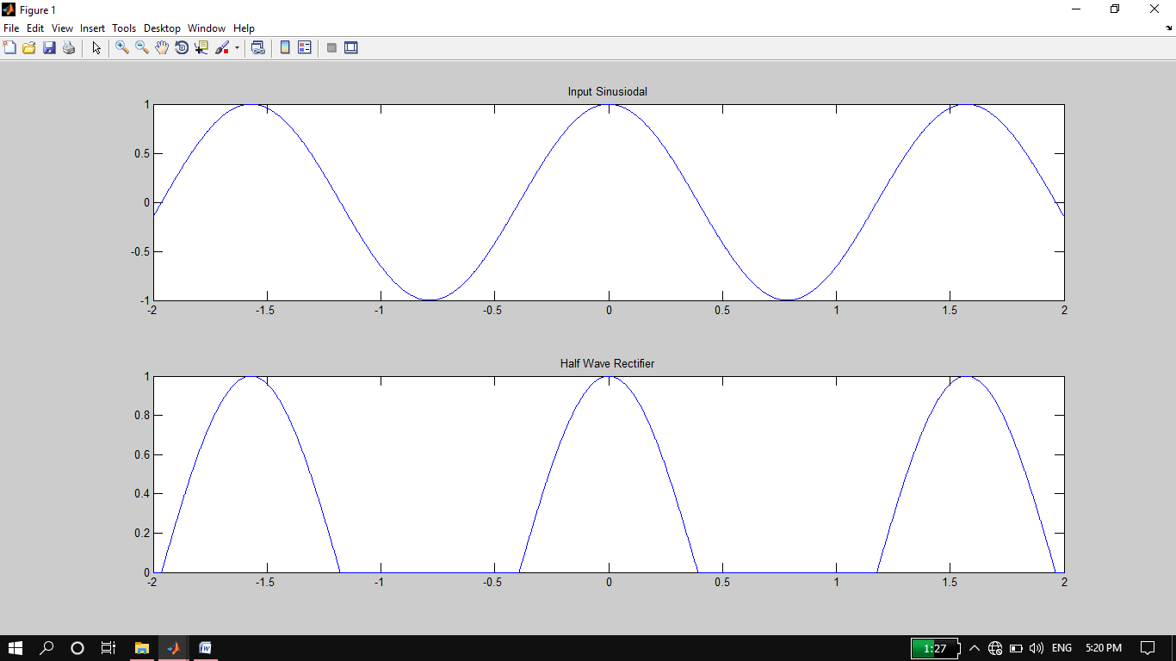

**THE END**